**INSTALLATION OF STM32**

**IN ARDUINO IDE**

**PROCEDURE:**

1. Install Arduino IDE
2. Go to File 🡪 Preferences in the IDE
3. A new dialogue box will appear called ‘Preferences’ will appear
4. In that , paste <http://dan.drown.org/stm32duino/package_STM32duino_index.json> in Additional Boards Manager URLs and press ok.
5. Go to Tools 🡪 Board 🡪 Boards Manager, a dialogue box called ‘Boards Manager’ will appear.
6. Search ‘stm32f1’

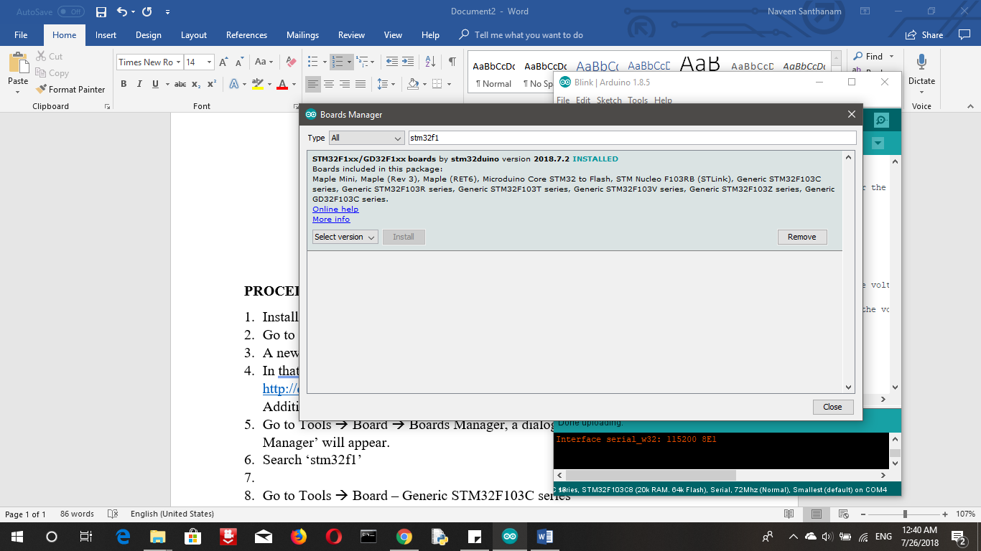

The screenshot is shown above.

1. Install it (It will take some 5 minutes).
2. Close the IDE and restart it.
3. Go to Tools 🡪 Board – Generic STM32F103C series

🡪 Variant – STM32F103C8

🡪 CPU Speed – 72Mhz

🡪 Upload method – Serial

1. Now, STM32F103C8T6 can be programmed using the Arduino IDE.